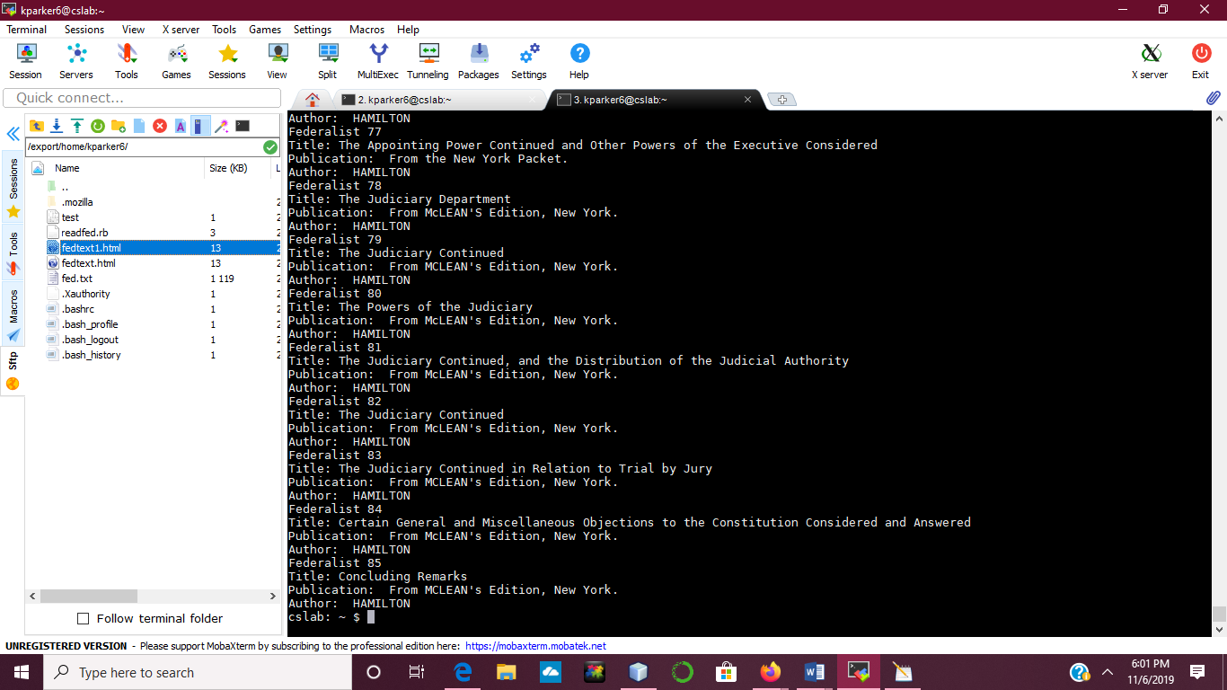

This is a screen shot of the program ran in MobaXterm on the command line.

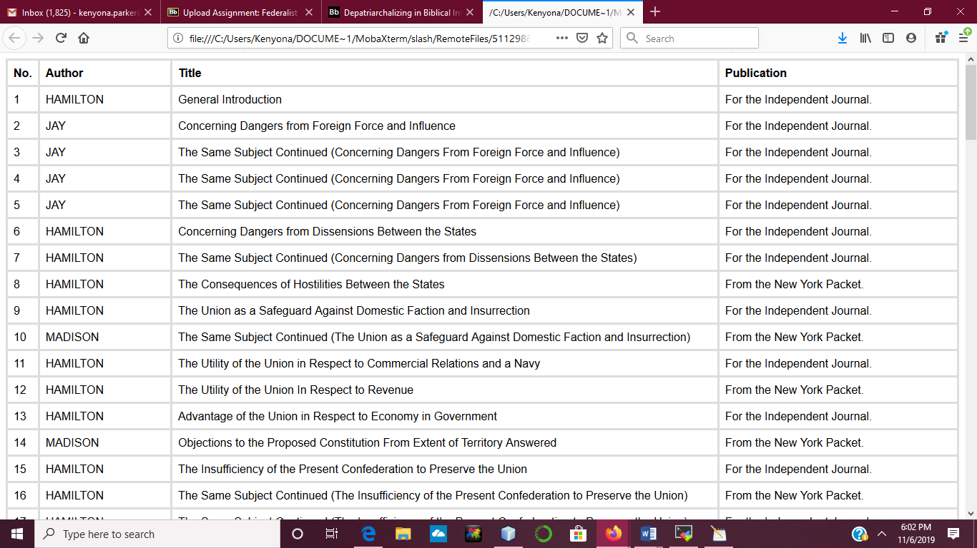

This is a screenshot of the html file ran in the browser.